JFS Task - 6
1.Fix the bug and errors
<html lang="en">
<head>
<title>Document
<body>
guvi
</title>
</head>
<div>
Lorem ipsum dolor sit amet consectetur adipisicing elit.
<div>
<div>
Guvi Geek Network
</div>
</body>
</html>
Bug 1:
<body> tag is written inside the <title> tag . it must be outside the <head> tag .
Bug 2:
<div> tags are placed outside the <body>
All HTML content must be inside <body>.
Bug 3:
tags order are invalid , should be closed in reversed order
Corrected :
<html lang="en">
<head>
<title>Document</title>
</head>
<body>
guvi
<div>
Lorem ipsum dolor sit amet consectetur adipisicing elit.
<div>
<div>
Guvi Geek Network
</div>
</div>
</div>
</body>
</html>

Inference :
1. HTML follows a fixed structure:
<html>
<head>
</head>
<body>
</body>
</html>

2. <title> must be inside <head>
It should contain only plain text.

3. All visible content must be inside <body>

4. Tags must be properly nested
Incorrect: <div><p></div></p>
Correct: <div><p></p></div>

5. Every opened tag must be closed
Self-closing tags are exceptions.
2.Try the Code below
Corrected Code :
<html lang="en">
<head>
<title>Document</title>
</head>
<body>
guvi
<div>
Lorem ipsum dolor sit amet consectetur adipisicing elit.
<div>
<div>
Guvi Geek Network
</div>
</div>
</div>
</body>
</html>

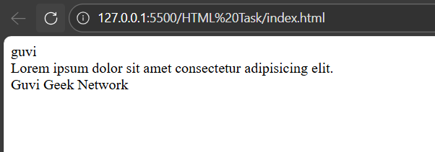
3.Design a contact us form with all fields as required.
Code :
<!DOCTYPE html>
<html lang="en">
<head>
<title>Contact Us</title>
</head>
<body>

<h2>Contact Us</h2>

<form>
<label>Name:</label><br>
<input type="text" required><br><br>

<label>Email:</label><br>
<input type="email" required><br><br>

<label>Phone:</label><br>
<input type="tel" required><br><br>

<label>Subject:</label><br>
<input type="text" required><br><br>

<label>Message:</label><br>
<textarea rows="4" cols="30" required></textarea><br><br>

<input type="submit" value="Submit">
</form>

</body>
</html>

Output :
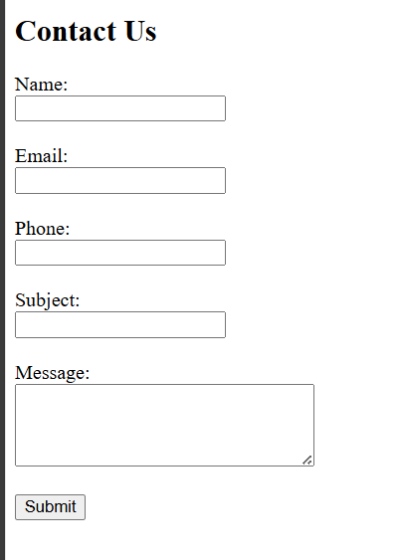
Inference :

1. <form> TAG
The <form> tag is used to group all input fields.
It represents a form that collects user input.

Example:
<form> ... </form>

2. INPUT FIELDS USED

2.1 Text Input
<input type="text">
Used for:
- Name
- Subject

2.2 Email Input
<input type="email">
Used for:
- Email address

HTML automatically checks for valid email format.

2.3 Telephone Input
<input type="tel">
Used for:
- Phone number

2.4 Textarea
<textarea></textarea>
Used for:
- Message field
Allows multi-line text input.

2.4. REQUIRED ATTRIBUTE
The "required" attribute is used to make a field mandatory.

Example:
<input type="text" required>

If a required field is empty and the user clicks Submit,
the browser shows a validation message.

No JavaScript is needed.

2.5. LABEL TAG
<label> is used to describe the input field.
It improves readability and accessibility.

2.6. SUBMIT BUTTON
<input type="submit">
Used to submit the form.
Form submission is blocked if required fields are empty.

2.7. VALIDATION

Validation is done automatically by the browser using:
- type="email"
- required attribute

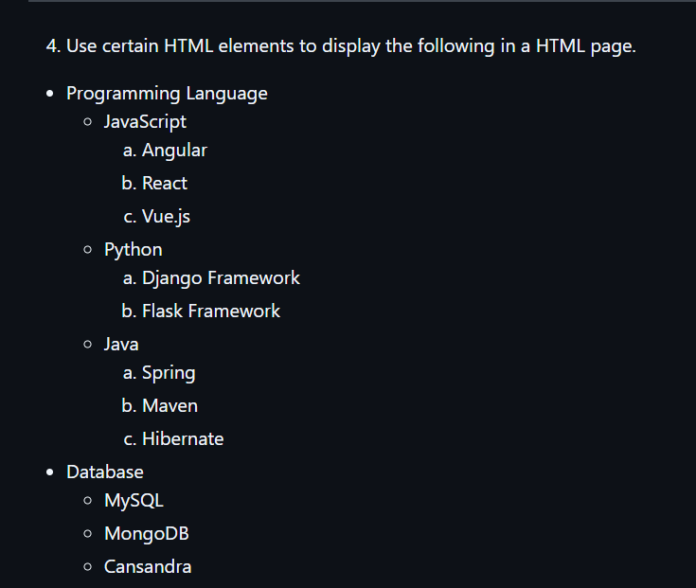

Code :
<!DOCTYPE html>
<html lang="en">
<head>
<meta charset="UTF-8">
<title>Technology Stack</title>
</head>
<body>

<h1>Programming Language</h1>

<h2>JavaScript</h2>
<ul>
<li>Angular</li>
<li>React</li>
<li>Vue.js</li>
</ul>

<h2>Python</h2>
<ul>
<li>Django Framework</li>
<li>Flask Framework</li>
</ul>

<h2>Java</h2>
<ul>
<li>Spring</li>
<li>Maven</li>
<li>Hibernate</li>
</ul>

<h1>Database</h1>
<ul>
<li>MySQL</li>
<li>MongoDB</li>
<li>Cassandra</li>
</ul>

</body>
</html>
Output :
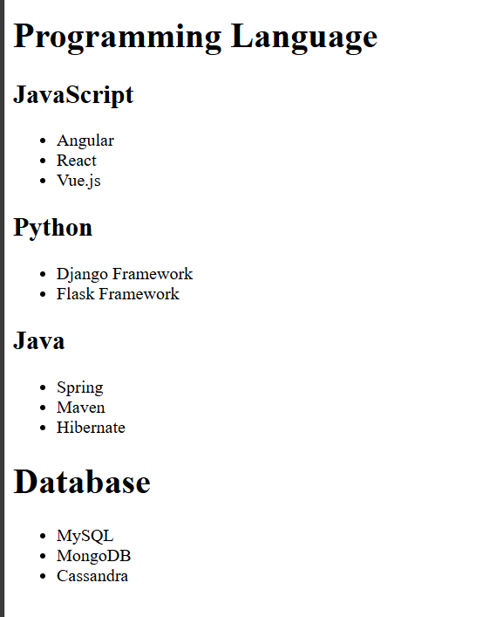
Inference :
1. Use semantic elements to represent meaning, not just appearance
Headings show hierarchy.
Lists show grouped data.

2. <h1> should be used for main sections
Example: Programming Language, Database.

3. <h2> is used for sub-categories
Example: JavaScript, Python, Java.

4. <ul> and <li> must be used for related items
Frameworks and tools belong inside lists.

5. Do not use <p> for structured data
Paragraphs are for text, not for grouping technologies.

6. Proper nesting is mandatory
<ul> must contain only <li> elements.

7. HTML structure must be readable and logical
Anyone reading the code should understand the content flow.

8. Semantic HTML improves:
Accessibility
SEO
Maintainability

9. One logical heading hierarchy per page
Do not jump from <h1> to <h4> randomly.

10. Clean HTML is expected in interviews and real projects
Browsers may render bad HTML, but professionals do not write it.
5.Create an element that helps you to open the https://google.com in separate new tab.
Code :
<!DOCTYPE html>
<html>
<head>
<title>Open Google</title>
</head>
<body>

<a href="https://google.com" target="_blank">Open Google</a>

</body>
</html>

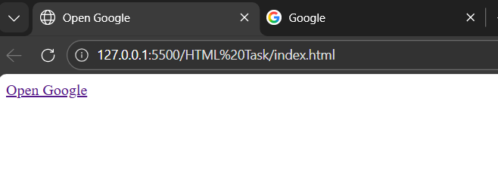

Inference :
1. <a> tag is called anchor tag.
2. href attribute specifies the URL to navigate to.
3. https://google.com is the destination link.
4. target="_blank" opens the link in a new browser tab.
5. Anchor tag is used for navigation between web pages or external sites.
6. Clicking the link triggers a GET request to the given URL.
6.In the form, add two radio buttons with grouping them for employee type(Salaried and own business)
<!DOCTYPE html>
<html>
<head>
<title>Employee Form</title>
</head>
<body>

<form>
<p>Employee Type:</p>

<input type="radio" name="employeeType" value="salaried"> Salaried
<br>

<input type="radio" name="employeeType" value="business"> Own Business
</form>

</body>
</html>
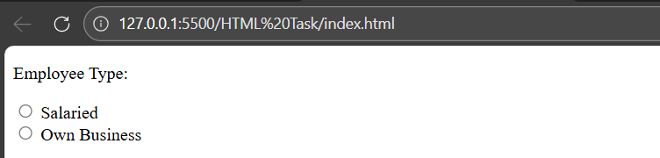
Inference :
1. <form> tag is used to collect user input.
2. <input type="radio"> creates a radio button.
3. Radio buttons allow the user to select only one option.
4. Same name attribute (employeeType) groups the radio buttons.
5. value attribute represents the selected option’s data.
6. <p> tag is used to display the label "Employee Type".
7. <br> tag moves the next radio button to a new line.
8. This form is commonly used to capture user choices.

7. kindly create a card size form by taking Aadhar or pan card

<!DOCTYPE html>
<html>
<head>
<title>Identity Card Form</title>
<style>
body {
font-family: Arial, sans-serif;
background-color: #f2f2f2;
}

.card {
width: 350px;
height: 220px;
border: 2px solid #000;
border-radius: 10px;
padding: 15px;
margin: 50px auto;
background-color: #ffffff;
}

.card h3 {
text-align: center;
margin: 0 0 10px 0;
}

.form-group {
margin-bottom: 8px;
}

label {
font-size: 12px;
font-weight: bold;
}

input {
width: 100%;
padding: 5px;
font-size: 12px;
box-sizing: border-box;
}

.row {
display: flex;
gap: 10px;
}

.row div {
flex: 1;
}
</style>
</head>
<body>

<div class="card">
<h3>Identity Card</h3>

<div class="form-group">
<label>Full Name</label>
<input type="text">
</div>

<div class="form-group">
<label>Aadhar / PAN Number</label>
<input type="text">
</div>

<div class="row">
<div class="form-group">
<label>Date of Birth</label>
<input type="date">
</div>
<div class="form-group">
<label>Gender</label>
<input type="text">
</div>
</div>
</div>

</body>
</html>

Output :
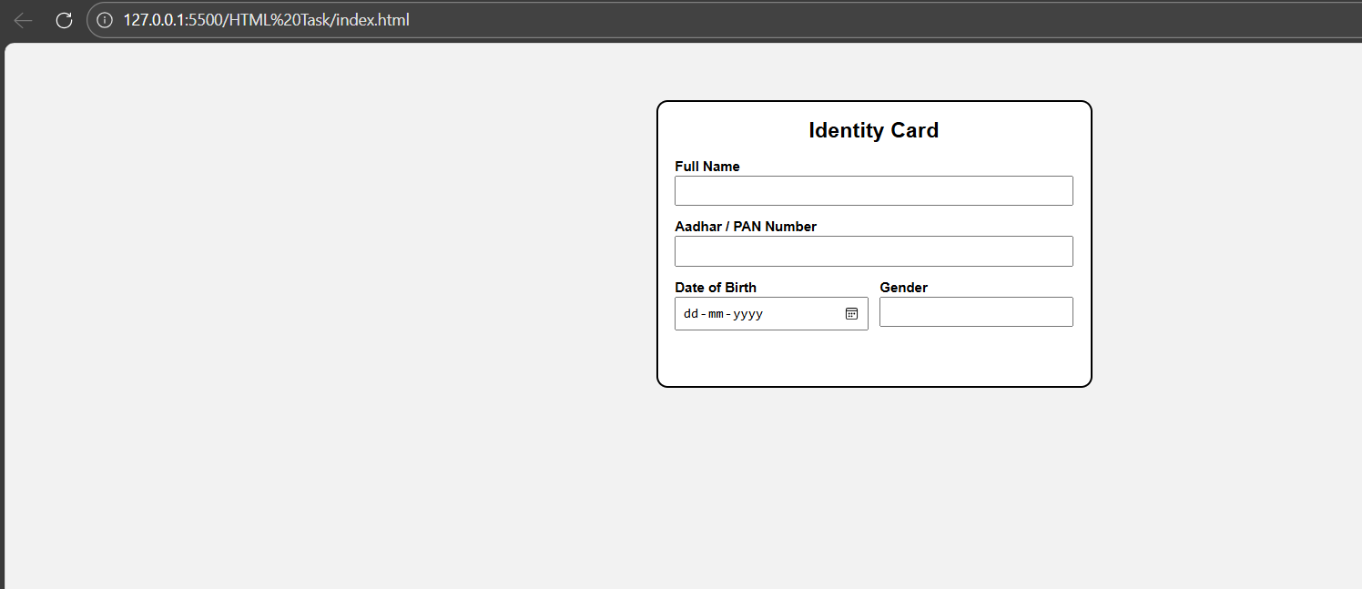
Inference :
- <!DOCTYPE html> declares the document as HTML5
- <html> is the root element of the web page
- <head> contains the title and internal CSS styles
- <style> is used to apply CSS within the same HTML file

- body styling provides background color and font formatting
- .card class creates a fixed-size card layout
- width and height maintain card-like dimensions
- border and border-radius give a clean card appearance
- margin auto centers the card on the page

- <h3> tag displays the form title
- .form-group organizes label and input fields
- <label> improves readability and accessibility
- <input> fields collect user details
- box-sizing ensures proper input alignment

- .row uses flex layout to align fields in a single row
- type="date" enables calendar-based date selection
- The design represents a real-world identity card form

8.Use the table tag to design given image
<!DOCTYPE html>
<html>
<head>
<title>Customer Table</title>
<style>
table {
border-collapse: collapse;
width: 70%;
margin: 20px auto;
font-family: Arial, sans-serif;
}

th, td {
border: 2px solid black;
padding: 8px 12px;
text-align: center;
}

th {
font-weight: bold;
}

.left {
text-align: left;
}
</style>
</head>
<body>

<table>
<tr>
<th rowspan="2">Customer</th>
<th colspan="3">Items</th>
<th colspan="2">Payments</th>
</tr>
<tr>
<th>Item</th>
<th>Qty</th>
<th>Price</th>
<th>Date</th>
<th>Amount</th>
</tr>

<tr>
<td rowspan="3" class="left">Customer Name</td>
<td>Item1</td>
<td>5</td>
<td>$400.00</td>
<td rowspan="2">12 Sep 2018</td>
<td rowspan="2">$3,000.00</td>
</tr>

<tr>
<td>Item2</td>
<td>10</td>
<td>$200.00</td>
</tr>

<tr>
<td>Item3</td>
<td>2</td>
<td>$500.00</td>
<td>18 Sep 2018</td>
<td>$2,000.00</td>
</tr>
</table>

</body>
</html>

Output :
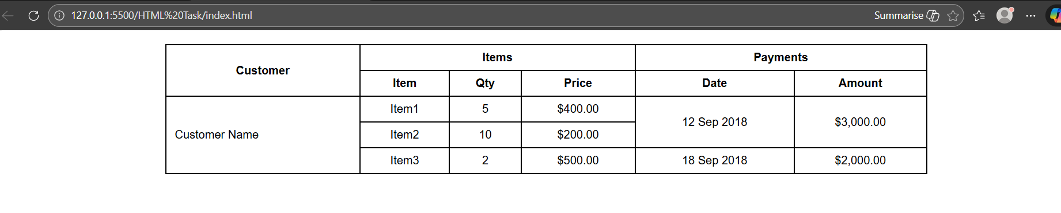
Inference :
1. Table layout depends on rows and columns.
2. All rows should follow the same column count.
3. colspan merges multiple columns into one cell.
4. Using colspan prevents layout breaking.
5. Image duplication happens when <img> is placed in multiple rows.
6. width attribute controls column distribution.
7. Tables are strict compared to div-based layouts.

9.Write HTML input tags snippet to show default values for all Form elements.
Code :
<!DOCTYPE html>
<html>
<head>
<title>Form Default Values</title>
</head>
<body>

<form>

<!-- Text -->
Name:
<input type="text" value="John Doe">
<br><br>

<!-- Password -->
Password:
<input type="password" value="123456">
<br><br>

<!-- Email -->
Email:
<input type="email" value="john@example.com">
<br><br>

<!-- Number -->
Age:
<input type="number" value="25">
<br><br>

<!-- Radio -->
Gender:
<input type="radio" name="gender" checked> Male
<input type="radio" name="gender"> Female
<br><br>

<!-- Checkbox -->
Skills:
<input type="checkbox" checked> Java
<input type="checkbox"> Python
<br><br>

<!-- Date -->
Date of Birth:
<input type="date" value="2000-01-01">
<br><br>

<!-- Select -->
Country:
<select>
<option>India</option>
<option selected>USA</option>
<option>UK</option>
</select>
<br><br>

<!-- Textarea -->
Address:
<textarea rows="3" cols="20">Chennai</textarea>
<br><br>

<!-- Submit -->
<input type="submit" value="Register">

</form>

</body>
</html>

Output :
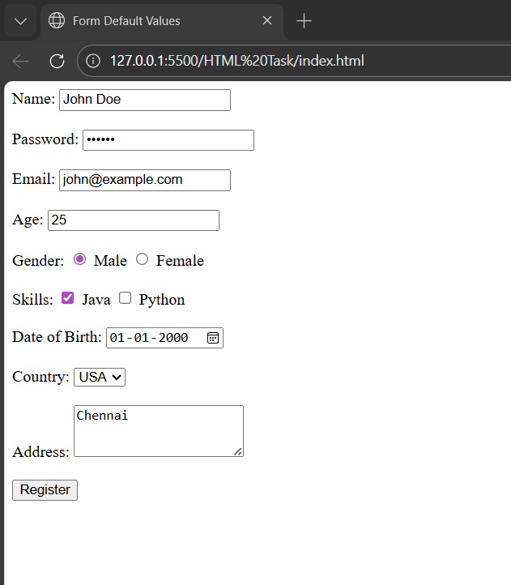
Inference :
1. value attribute sets default value for input fields.
2. checked attribute sets default selection for radio and checkbox.
3. selected attribute sets default option in dropdown.
4. Textarea default value is written inside the tag.
5. Date input uses YYYY-MM-DD format.
6. Default values improve user experience.

10.In your, HTML page add the below line and Highlight it without using any CSS.
"HTML & CSS is awesome"
Code :
<!DOCTYPE html>
<html>
<head>
<title>Highlight Text</title>
</head>
<body>

<p><mark>HTML & CSS is awesome</mark></p>

</body>
</html>
Output :

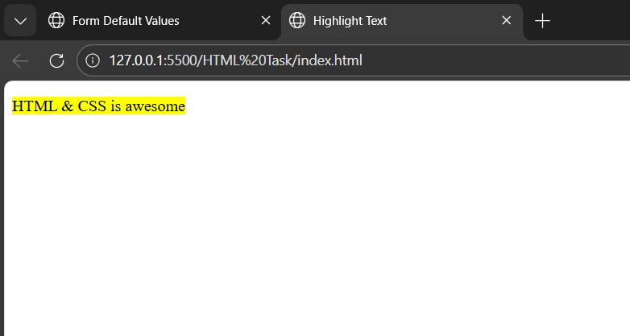
Inference :
1. <mark> tag is used to highlight text.
2. It highlights content without using CSS.
3. Highlight color is applied by the browser default.
4. <mark> is a semantic HTML tag.
5. Useful for emphasizing important text.
11.Create an HTML page, which should contain all types of input elements.
Code :

<!DOCTYPE html>
<html>
<head>
<title>All Input Types</title>
</head>
<body>

<h2>HTML Form – All Input Types</h2>

<form>

<!-- Text -->
Name:
<input type="text">
<br><br>

<!-- Password -->
Password:
<input type="password">
<br><br>

<!-- Email -->
Email:
<input type="email">
<br><br>

<!-- Number -->
Age:
<input type="number">
<br><br>

<!-- Tel -->
Phone:
<input type="tel">
<br><br>

<!-- URL -->
Website:
<input type="url">
<br><br>

<!-- Radio -->
Gender:
<input type="radio" name="gender"> Male
<input type="radio" name="gender"> Female
<br><br>

<!-- Checkbox -->
Skills:
<input type="checkbox"> Java
<input type="checkbox"> HTML
<br><br>

<!-- Date -->
Date of Birth:
<input type="date">
<br><br>

<!-- Time -->
Time:
<input type="time">
<br><br>

<!-- Color -->
Favorite Color:
<input type="color">
<br><br>

<!-- Range -->
Experience:
<input type="range">
<br><br>

<!-- File -->
Upload Resume:
<input type="file">
<br><br>

<!-- Hidden -->
<input type="hidden" value="12345">

<!-- Submit -->
<input type="submit" value="Submit">

<!-- Reset -->
<input type="reset" value="Reset">

</form>

</body>
</html>
Output :
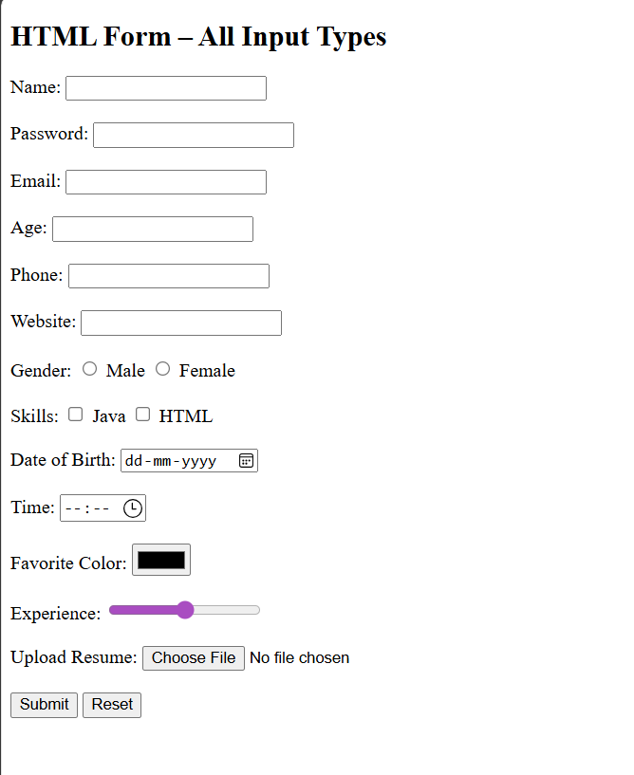
Inference :

1. <input> tag is used to take user input.
2. type attribute defines the kind of input.
3. Radio buttons use same name to form a group.
4. Checkbox allows multiple selections.
5. Hidden input is not visible to users.
6. Submit sends form data.
7. Reset clears all entered values.

